
H
CATHOLIC JUNIOR COLLEGE
Preliminary Examination 2009
Higher 2

CHEMISTRY 9746/03

Paper 3 Free Response
15 September 2009

2 hours
Candidates answer on separate paper.

Additional Materials: Data Booklet

READ THESE INSTRUCTIONS CAREFULLY

Write your name and class in the spaces on the writing paper.
Write in dark blue or black pen on both sides of the writing paper.
You may use a soft pencil for any diagrams, graphs or rough working.
Do not use correction fluid.

Answer any four questions.
A Data Booklet is provided.
You are reminded of the need for good English and clear presentation in your answers.

The number of marks is given in brackets [ ] at the end of each question or part question.
At the end of the examination, fasten all the answer scripts securely together.

This document consists of 8 printed pages and no blank pages.


CJC Chemistry Department

© CJC 2009
Answer any four questions

1 Fireworks are an integral part of the Olympics opening ceremony. One of the most spectacular displays in recent history took place at the 2006 Torino Winter Olympics, where the largest ever Olympic rings were lit up in fireworks.

(a) The colours of fireworks are due to various colour-producing chemicals present, of which compounds of the Group II metals are particularly important.

Another component of fireworks is the oxidiser, which decomposes upon heating to provide oxygen for burning of the fireworks fuel. One such oxidiser in common use is potassium nitrate, KNO₃, which gives potassium nitrite, KNO₂, and oxygen gas when heated.

(i) Write a balanced equation for the decomposition of KNO₃.

(ii) From your answer in (a)(i), explain, including any relevant equations, why potassium nitrate is a better choice as an oxidiser as compared to magnesium nitrate.
[3]

(b) When a 2.75 g mixture of potassium nitrate and a Group II carbonate from a red firework was heated thoroughly, enough oxygen was produced to oxidise 0.0141 mol of aluminium, which is used as fuel in fireworks. In addition, when the gases produced were cooled to room temperature and pressure, it was found that 100 cm³ of carbon dioxide was produced.
Given that complete decomposition of the nitrate and carbonate took place, find the identity of the Group II metal used. [4]

(c) Phosphorus and sulfur have various applications in pyrotechnic materials, including fireworks.

(i) Predict, with reasons, how the radius of P^{3–} compares with that of S^{2–}.

(ii) Both phosphorus and sulfur exhibit two different oxidation states in their oxides and chlorides.
Explain why phosphorus can form chlorides of two different oxidation states, while nitrogen can only form one chloride, NCl₃.
[4]

(d) Another fuel also used in fireworks is gallic acid. A closely related compound which is used as a base material in the production of Tamiflu, an antiviral influenza drug, is shikimic acid.
C
O
2
H
O
H
O
H
O
H
C
O
2
H
O
H
O
H
O
H
gallic acid
shikimic acid

State one chemical test, other than reaction with oxidising agents, by which gallic acid and shikimic acid can be distinguished from each other, and describe what will be observed. [2]

(e) (i) Outline how the following transformation can be achieved, providing details of any necessary reagents and conditions, as well as the structures of any intermediates formed.
C
H
2
C
l
C
H
2
C
O
2
H

(chloromethyl)benzene

(ii) When warmed with aqueous sodium hydroxide followed by an excess of dilute nitric acid and aqueous silver nitrate, (chloromethyl)benzene gives a white precipitate. However, neither 2-chloromethylbenzene nor (fluoromethyl)benzene gives a precipitate. Suggest explanations for the above observations.
[7]
[Total: 20]

2 (a) Two hydrocarbons of molecular formula C₄H₁₀ are n-butane and i-butane. n-butane is a straight chained butane molecule whereas i-butane is a branched chain molecule.
(i) Draw the full structural formula of both forms of butane and explain which form is expected to have the higher boiling point.
(ii) Give the IUPAC name of i-butane.
(iii) i-butane is used in refrigeration systems in place of CFCs and HCFCs that cause ozone depletion. Give a reason why i-butane does not cause ozone depletion.
- n-butane is sold as bottled fuel for cooking and camping. Given that the enthalpy change of the combustion of n-butane is -2877 kJ mol⁻¹, calculate the mass of n-butane needed to bring 1 dm³ of water at room temperature to boiling point. Assume the burner is only 85% efficient.
(Given: M_{r} of n-butane = 58.0; specific heat capacity of water = 4.2 J cm⁻³ ºC⁻¹)
(v) Excess n-butane reacts with Cl₂ in the presence of uv light to give a mixture of three monochlorinated products. Draw clearly the three isomeric products formed and name the mechanism of the reaction.
[14]

(b) Sodium chlorate(V), NaClO₃, is an ingredient in weed-killer. In the industry, sodium chlorate(V) is synthesized from the electrolysis of hot NaCl solution in a mixed electrode tank:
NaCl + 3H₂O → NaClO₃ + 3H₂
(i) Suggest another method of synthesising sodium chlorate(V) and write a balanced equation for the reaction.
(ii) NaClO₃ obtained in (b)(i) is purified by a process called crystallisation. NaClO₃ can undergo a disproportionation reaction to form NaCl and NaClO₄.
The half equation showing ClO₃⁻ being reduced to Cl⁻ is shown below:
ClO₃⁻ + 6H⁺ + 6e⁻ → Cl⁻ + 3H₂O
Write the half equation to show ClO₃⁻ being oxidised to ClO₄⁻, and hence write a balanced equation to show the disproportionation of ClO₃⁻.
(iii) Suggest, with a reason, whether the disproportionation of ClO₃⁻ is pH dependent.
[6]
[Total: 20]
3 H₂O₂ reacts with I⁻ ions to give I₂ and water.

H₂O₂(aq) + 2 I⁻(aq) + 2 H⁺(aq) → I₂(aq) + 2 H₂O(l)

The kinetics of this reaction vary with pH.

(a) To study the rate of this reaction, fixed amounts of sodium thiosulfate, Na₂S₂O₃, and starch solutions were added to different concentrations of the reagents. Suggest why these solutions were needed. Include any relevant equation in your answer. [2]

(b) A series of experiments was carried out at 25 ºC and the following results were obtained. In each case, [H⁺] was kept constant by using a buffer solution.

Expt number | pH of buffer | [H₂O₂]/mol dm⁻³ | [I⁻]/mol dm⁻³ | Initial rate/  mol dm⁻³ s⁻¹
1 | 5.0 | 0.10 | 0.10 | 1.2 × 10⁻⁴
2 | 5.0 | 0.20 | 0.10 | 2.5 × 10⁻⁴
3 | 5.0 | 0.20 | 0.20 | 4.7 × 10⁻⁴
4 | 4.0 | 0.20 | 0.20 | 4.8 × 10⁻⁴
5 | 0.53 | 0.20 | 0.20 | 2.1 × 10⁻³
6 | 0.40 | 0.20 | 0.20 | 2.8 × 10⁻³

(i) Using data from experiments 1-4, find the order of reaction with respect to [H⁺], [H₂O₂] and [I⁻] respectively. Hence, write a rate equation for the reaction when the pH is between 4 and 5.

(ii) Evaluate the rate constant for the reaction over this pH range.
(iii) Using the data from experiments 5 and 6, write the rate equation for the reaction when the pH is low. (Assume that the orders of reaction with respect to both [H₂O₂] and [I⁻] do not change with pH).

(iv) What conclusion can you draw from the rate equations obtained above?

(v) Suggest a 3-step mechanism for the reaction at pH 5 given the following:
- The first step is the rate-determining step.
- One of the intermediate products is OI ⁻ which can act as a base.
[10]

(c) The stability constant for a complex ion, K_{stab}, gives a measure of the stability of a complex.

Consider the equation for the formation of the complex ion, [Fe(SCN)(H₂O)₅]²⁺:

[Fe(H₂O)₆]³⁺(aq) + SCN⁻(aq) [Fe(SCN)(H₂O)₅]²⁺(aq) + H₂O(l)

The stability constant, K_{stab}, is given by:
K_{stab} = 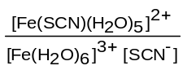

The greater the magnitude of K_{stab}, the more stable is the complex that is formed.

The following table lists some iron complexes together with their colours and their stability constants.

complex | colour | K_{stab}
[Fe(SCN)(H₂O)₅]²⁺(aq) | deep red | 1 × 10²
[Fe(CN)₆]⁴⁻(aq) | pale yellow | 1 × 10²⁴
[Fe(CN)₆]³⁻(aq) | orange yellow | 1 × 10³¹

(i) Use the data in the table to predict and explain the effect (if any) of adding CN⁻(aq) ions on the colour of a solution containing [Fe(SCN)(H₂O)₅]²⁺(aq).

(ii) As shown by their Eº values in the Data Booklet, [Fe(CN)₆]³⁻(aq) is a weaker oxidising agent than Fe³⁺(aq). By using the data in the table above and relevant Eº values, explain why this is the case.
[5]

(d) In order to replace the worn-out silver coating on a trophy, it is estimated that 0.50 g of silver needs to be electroplated onto it. Calculate the length of time that a current of 0.20 A has to be passed through the electrolytic cell in order to achieve this. [3]
[Total: 20]

4 The following table gives the values of the ionic product of water, K_{w} at different temperatures.

Temperature / ºC | K_{w} / mol² dm⁻⁶
10 | 0.3 x 10⁻¹⁴
20 | 0.7 x 10⁻¹⁴
25 | 1.0 x 10⁻¹⁴
30 | 1.5 x 10⁻¹⁴
40 | 2.9 x 10⁻¹⁴
50 | 5.4 x 10⁻¹⁴

(a) (i) Calculate the pH of water at 40 ºC.

(ii) Is water neutral at 40 ºC? Explain your answer.

(iii) Explain whether the dissociation of water is endothermic or exothermic.
[4]

(b) Ethylamine reacts with dilute aqueous hydrochloric acid to give CH₃CH₂NH₃⁺Cl⁻. Calculate the pH of an aqueous solution of the salt, CH₃CH₂NH₃⁺Cl⁻, of concentration
0.0200 mol dm⁻³ at 40 ºC (pK_{b} = 3.25 for CH₃CH₂NH₂ at 40 ºC). [3]
(c) In China, in certain dairy farms, water has been added to raw milk to increase its volume. As a result of this adulteration by dilution, the milk has a lower protein concentration. Companies using the milk for further production (e.g. of powdered infant formula) normally check the protein level through a test measuring nitrogen content. The addition of melamine increases the nitrogen content of the milk and therefore its apparent protein content. However, melamine is toxic and four infants in China have died and at least 53000 are reportedly ill, many seriously so, having been fed milk adulterated with melamine.
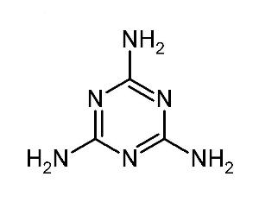
In fact, apart from melamine, other compounds can also be added to milk powder to increase its nitrogen content with equally disastrous consequences. Compounds such as urea, NH₂CONH₂ or ammonium nitrate, NH₄NO₃, or even hydrazine, NH₂NH₂, have been considered.
melamine
Melamine has the molecular structure as shown. The double bonds are delocalised, similar to that of the benzene ring structure.

Based on the information given:

(i) Calculate the % of nitrogen by mass in melamine.

(ii) Hence, or otherwise, deduce which one of the above mentioned compounds (melamine, urea, ammonium nitrate and hydrazine) is best used to artificially boost the nitrogen content of milk, regardless of its toxicity.

(iii) Explain why melamine is basic.

(iv) Suggest with reasons, how the basicity of melamine might compare with that of ethylamine.

[6]
(d) Write down the structure of the organic product formed when 1 mol of melamine reacts with:

(i) 1 mol of ethanoyl chloride,
(ii) 1 mol of aqueous ethanoic acid,
(iii) 1 mol of bromoethane.
[3]

(e) When melamine is treated with excess bromoethane, a compound of relative formula mass of 291 is obtained. When aqueous silver nitrate is added to the compound, an immediate precipitate is seen. Deduce the structure of the compound. [2]

(f) Cyanuric acid (M_{r} = 129) exists as a keto-enol form as shown below. It is possible for melamine (M_{r} = 126) and cyanuric acid to interact non-covalently with each other to form a melanine-cyanuric acid complex. The interaction is reminiscent to that seen in DNA base pairing. Measurement of the relative molecular mass of the complex indicates a value of 255.

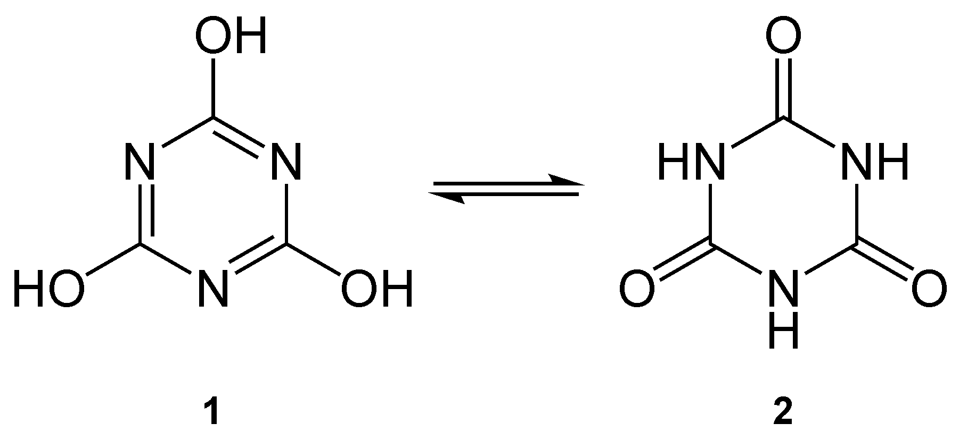
cyanuric acid

Deduce the molecular structure of the melanine-cyanuric acid complex, showing and naming clearly the interaction between the two molecules. [2]
[Total: 20]

5 (a) CH₃CHO can react with HCN, using a trace of NaCN to form the corresponding cyanohydrin.

Name the type of reaction and describe the mechanism for this reaction, including curly arrows showing the movement of electrons, and intermediate. [3]

(b) Pentan-2-one can be converted into propyl ethanoate using a peroxyacid, RCO₃H. This is named the Baeyer-Villiger reaction.
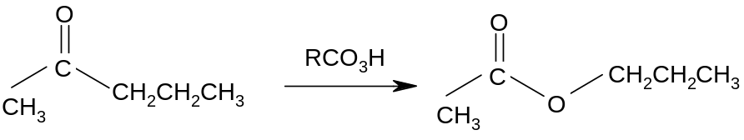

What is the type of reaction shown above? [1]

(c) Esters and acid anhydrides can be reduced by LiAlH₄, followed by addition of acid. An example of the reduction of propyl ethanoate is shown:
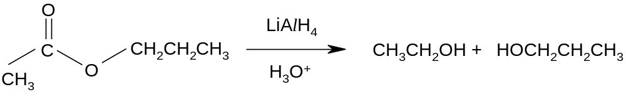

Predict the structures of the organic products formed when the following are treated with LiAlH₄, followed by addition of acid.
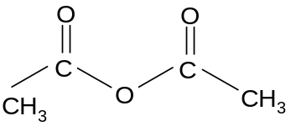
(i) (ii)
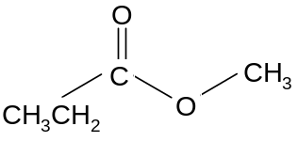

an acid anhydride
[2]

(d) One of the essential oils found in lemon grass is Nerol, C₁₀H₁₈O. Its isomer A is made in the laboratory. When a piece of sodium metal is added to a pure sample of A, immediate effervescence is observed. A can be oxidised to B, C₁₀H₁₆O₂ using acidified potassium dichromate(VI).

1 mole of A readily decolourises 2 moles of bromine dissolved in a suitable organic solvent. With oxidation of A using hot acidified potassium manganate(VII) solution, C, C₃H₆O, D, C₅H₈O₃ and E, C₂H₂O₄ are formed initially. Both C and D result in the formation of a yellow precipitate when treated with alkaline aqueous iodine.

On treatment of B with steam in the presence of the catalyst, concentrated H₃PO₄, at high temperature and pressure, followed by excess concentrated H₂SO₄, a cyclic ester F as shown below is formed as one of the major products.

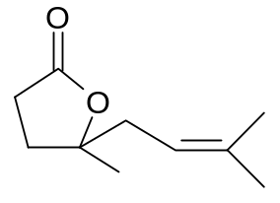
Deduce the structures of A, B, C, D and E, explaining how you arrive at your answers and the chemistry of the reactions involved. [14]
[Total: 20]

